COURSE NAME: Theory of Computation COURSE CODE: CSA1304

COURSE OUTCOME COVERED

CO5: Design Pushdown Automata and analyze their equivalence with Context-Free Grammars through formal construction and proof techniques. ( BL :3)

Assessment Tool Weightage: 40%

QUESTIONS: 5 Total Marks:25
Duration : 1 Hour

Constraint Based Problem

Code of Conduct:

I M SRIVARSHA -192371010 (Name / Reg No) certify that this submission is my original work and that I have adhered to the guidelines specified for this assessment.
I understand that any violation of academic integrity rules will result in disciplinary action.

Signature of the student:
SRIVARSHA M

- Design a Pushdown Automaton that accepts the language L = { aⁿbⁿ | n ≥ 1 }
Constraint: You are allowed to use only one stack symbol (besides initial symbol)

- CFG to PDA Conversion with Limited Productions Given a Context-Free Grammar:
S → aSb | ab
Construct an equivalent PDA.
Constraint: PDA must be constructed using only 2 states

- PDA to CFG Conversion with Restricted Variables Convert a given PDA into an equivalent CFG.
Constraint: The resulting CFG must use at most 3 variables (non-terminals)

- Turing Machine with Limited Tape Movement Design a Turing Machine to recognize the language L = { ww | w ∈ {0,1}* }
Constraint: The tape head can move only to the right (no left movement allowed)

- Consider a language L = { aⁿbⁿcⁿ | n ≥ 1 }
Constraint: Design a Turing Machine for L

Question 1 — PDA for L = { aⁿbⁿ | n ≥ 1 } (single stack symbol)
Constraint: only one stack symbol besides the initial stack symbol is allowed.
Idea
Every 'a' pushes exactly one working symbol A onto the stack. Every 'b' pops one A. If the number of a's equals the number of b's, the stack empties (down to the initial symbol Z0) exactly when the input ends, so the string is accepted. Only one working symbol, A, is ever needed — its count on the stack is what tracks the number of unmatched a's.
Formal Definition
M = (Q, Σ, Γ, δ, q0, Z0, F)
Q = {q0, q1, q2}
Σ = {a, b}
Γ = {Z0, A} (Z0 = initial symbol, A = the ONLY working symbol)
q0 = start state, Z0 = initial stack symbol, F = {q2}
Transition Function δ
δ(q0, a, Z0) = (q0, A Z0) — first a: push A above Z0
δ(q0, a, A) = (q0, A A) — further a's: push another A
δ(q0, b, A) = (q1, ε) — first b: pop one A, switch to popping mode
δ(q1, b, A) = (q1, ε) — remaining b's: keep popping A
δ(q1, ε, Z0) = (q2, Z0) — stack empty of A's ⇒ accept
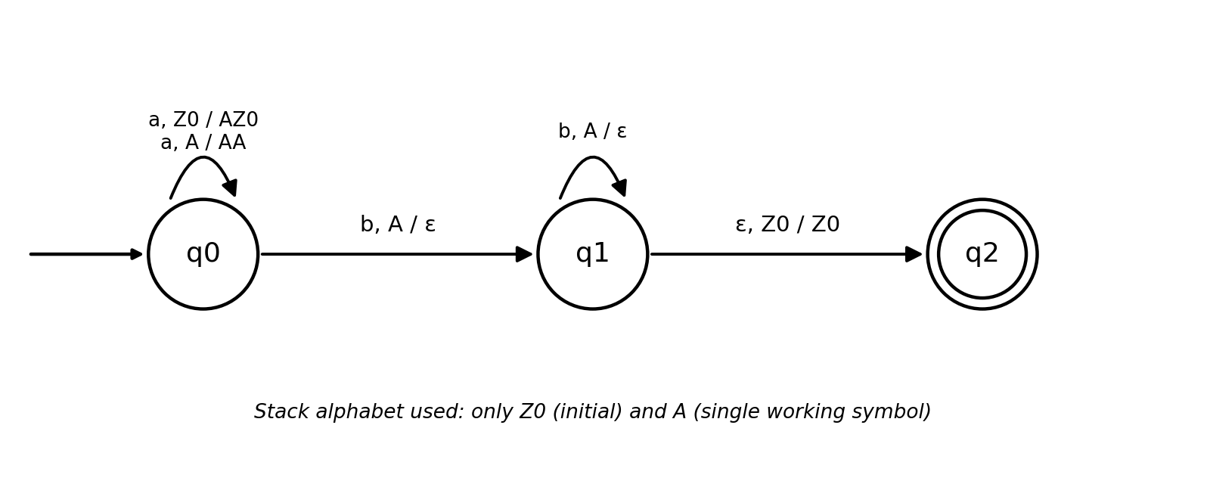
Fig. 1 — PDA transition diagram for L = aⁿbⁿ (n ≥ 1), using only stack symbols {Z0, A}
Trace for input "aabb"
(q0, aabb, Z0) ⊢ (q0, abb, AZ0) ⊢ (q0, bb, AAZ0)
⊢ (q1, b, AZ0) ⊢ (q1, ε, Z0) ⊢ (q2, ε, Z0) → ACCEPTED
The PDA correctly rejects strings such as "aab" (stack still holds A when input ends) and "abb" (attempts to pop A when the stack top is already Z0).

Question 2 — CFG to PDA: S → aSb | ab (only 2 states)
Constraint: the constructed PDA must use only 2 states.
Idea
The standard CFG-to-PDA construction needs only a single "working" state that repeatedly expands the top-of-stack variable using the grammar's productions and matches terminals against the input; a second state is used only to move the start variable S onto the stack. This keeps the whole machine to exactly two states, q0 and q1.
Formal Definition
M = (Q, Σ, Γ, δ, q0, Z0, F), Q = {q0, q1}, F = {q1}
Σ = {a, b}, Γ = {Z0, S, a, b}
Transition Function δ
δ(q0, ε, Z0) = (q1, S Z0) — load the start variable S onto the stack
δ(q1, ε, S) = (q1, a S b) — apply production S → aSb
δ(q1, ε, S) = (q1, a b) — apply production S → ab
δ(q1, a, a) = (q1, ε) — match terminal a
δ(q1, b, b) = (q1, ε) — match terminal b
δ(q1, ε, Z0) = (q1, ε) — pop Z0 to empty the stack ⇒ accept
Acceptance is by empty stack (equivalently, q1 can be marked final as shown, since after the stack empties no further move is needed).
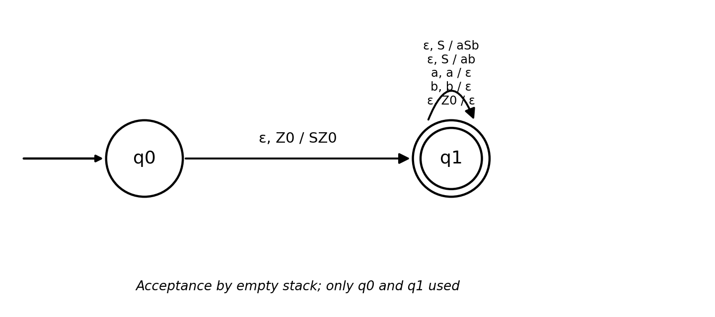
Fig. 2 — 2-state PDA equivalent to S → aSb | ab
Trace for input "aabb"
(q0, aabb, Z0) ⊢ (q1, aabb, SZ0) ⊢ (q1, aabb, aSbZ0)
⊢ (q1, abb, SbZ0) ⊢ (q1, abb, abbZ0) ⊢ (q1, bb, bbZ0)
⊢ (q1, b, bZ0) ⊢ (q1, ε, Z0) ⊢ (q1, ε, ε) → ACCEPTED

Question 3 — PDA to CFG (at most 3 variables)
Constraint: the resulting CFG must use at most 3 non-terminal variables.
We convert the PDA constructed in Question 1 (which accepts L = aⁿbⁿ, n ≥ 1) back into an equivalent context-free grammar, using the standard state-pair construction, but keeping only the variables that are actually reachable/useful.
General Construction Rule
For a PDA with states p, q, r, s, the algorithm builds one non-terminal A(p,q) for every pair of states, meaning "A(p,q) derives exactly the strings that drive the PDA from state p with empty stack-top to state q with the same stack-top removed", using three kinds of productions:
- Type 1 (base): A(p,p) → ε
- Type 2 (nested match): A(p,q) → a · A(r,s) · b whenever δ(p,a,X)=(r, YX) is a push and δ(s,b,Y)=(q, ε) is the matching pop
- Type 3 (sequencing): A(p,q) → A(p,r) · A(r,q) for any intermediate state r
Applying it to the Q1 PDA
Only 3 of the (Q×Q) pairs are ever needed for this machine, so we name them directly:
- S = A(q0, q2) — the start variable (whole computation, q0 to the accepting state q2)
- B = A(q0, q1) — the part of the run that pushes and pops the A's (q0 to q1)
- C = A(q1, q2) — the leftover ε-move from q1 to q2
Derived Productions
S → B C (Type 3: q0 to q2 goes through the intermediate state q1)
C → ε (Type 1: the only q1→q2 move is δ(q1,ε,Z0)=(q2,Z0), no symbol consumed)
B → a B b (Type 2: push A at q0→q0, matching pop A at q1→q1)
B → a b (Type 2 base pairing: push A at q0→q0, matching pop A at q0→q1)
Since C → ε, the start symbol effectively behaves as S → B, and B → aBb | ab. Substituting S directly for B gives the simplified, equivalent grammar:
S → aSb | ab
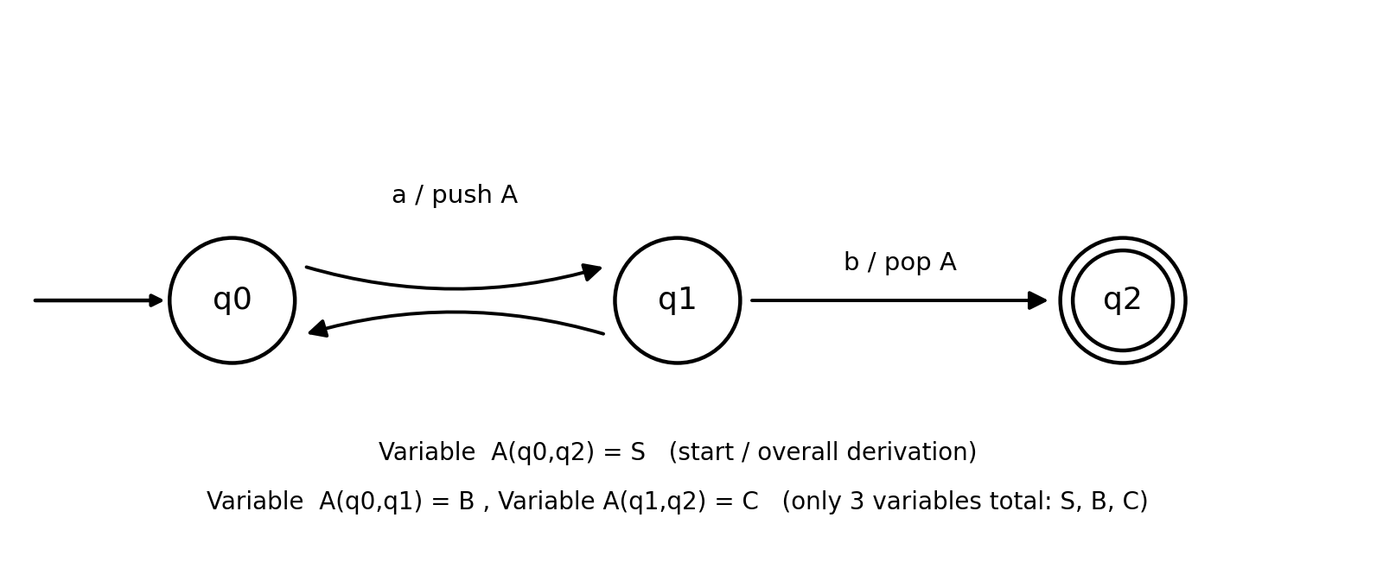
Fig. 3 — PDA of Question 1 with its states labelled by the 3 CFG variables S, B, C
This grammar generates exactly {aⁿbⁿ | n ≥ 1}, matching the language of the original PDA, and uses only 3 variables (S, B, C) as required — note it is also the same grammar given in Question 2, confirming the equivalence.

Question 4 — TM for L = { ww | w ∈ {0,1}* } (head moves only right)
Constraint: the tape head can move only to the right — no left movement is allowed.
Why a normal construction fails
The usual way to recognise ww is to repeatedly bounce the head left and right, cancelling a symbol from the first half against the matching symbol in the second half. With right-only movement that approach is impossible, since a head that has moved past a cell can never return to it.
Idea — three read-only heads moving at different speeds
We use a Turing machine with three tapes (equivalently, three read-only heads on separate copies of the input), every head moving strictly to the right, never left. Two heads race each other to locate the midpoint without ever backing up, and the third head starts its rightward scan only after the midpoint is found — starting later is still "only moving right", it simply begins its journey later in time.
- Tape H ("hare"): moves 2 cells to the right on every step.
- Tape T ("tortoise"): moves 1 cell to the right on every step, in lock-step with H.
- Tape C ("comparator"): stays parked on cell 1 while H and T run; once H reaches the blank at the end of the input, T is (by construction) sitting exactly on the midpoint. Only then does C begin moving right, one cell per step, together with T.
Formal Behaviour
Phase 1 (find midpoint):
step the pair (H,T) together: H += 2 cells, T += 1 cell, each step
if H reads a blank while T is mid-cell (odd total length) → REJECT
when H first reads blank ⊔, T is on cell n+1 (n = |w|) → go to Phase 2
Phase 2 (compare halves):
release C from cell 1; now step (C,T) together, both += 1 cell each step
if symbol under C ≠ symbol under T at any step → REJECT
if T reads blank ⊔ while C has compared all n symbols → ACCEPT
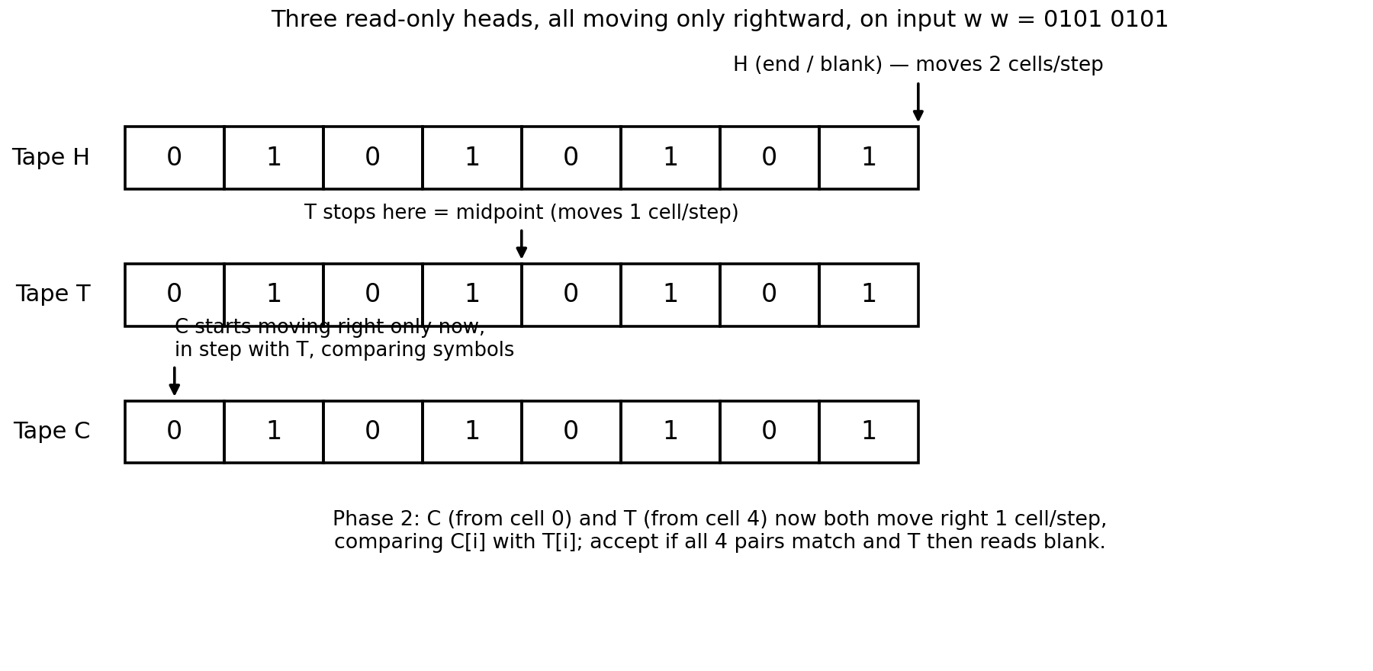
Fig. 4 — Locating the midpoint with a fast/slow head pair, then comparing the two halves left-to-right, using only rightward moves throughout
Why it works
Because H always travels exactly twice as far as T in the same number of steps, T is guaranteed to be standing on cell n+1 — the first cell of the second half — at the exact moment H exhausts the input of length 2n. Comparator C, having been held stationary at cell 1 throughout Phase 1, is free to make its own uninterrupted rightward pass through the first half in perfect lock-step with T's rightward pass through the second half — so w[i] is compared against w[n+i] for every i, without any head ever moving left.
Trace for w = 01, input ww = 0101
Phase 1: H: 1→3→5(blank); T: 1→2→3 (n=2, midpoint = cell 3)
Phase 2: C starts at 1, T continues from 3
step 1: C reads tape[1]=0, T reads tape[3]=0 → match
step 2: C reads tape[2]=1, T reads tape[4]=1 → match
T now reads blank, C has compared 2 symbols → ACCEPT

Question 5 — TM for L = { aⁿbⁿcⁿ | n ≥ 1 }
Idea
Repeatedly cross off one a, the next unmarked b, and the next unmarked c, sweeping left to right to find and mark each one and sweeping back to the start afterwards. If, after crossing off equal numbers of a's, b's and c's, no unmarked a's, b's or c's remain and the tape read X's followed by Y's followed by Z's in the correct order, the string is accepted.
Formal Definition
M = (Q, Σ, Γ, δ, q0, ⊔, F)
Q = {q0, q1, q2, q3, qA}, Σ = {a,b,c}, Γ = {a,b,c,X,Y,Z,⊔}, F = {qA}
Transition Function δ (informal, standard multi-pass marking)
δ(q0, a, X) = (q0, X, R) — skip already-marked a's
δ(q0, a, _) = (q1, X, R) — mark the next unmarked a as X, move right
δ(q1, a, _) = (q1, a, R); δ(q1, Y, _) = (q1, Y, R) — skip to the first unmarked b
δ(q1, b, _) = (q2, Y, R) — mark that b as Y
δ(q2, b, _) = (q2, b, R) — skip remaining unmarked b's
δ(q2, c, _) = (q3, Z, L) — mark the first unmarked c as Z, reverse
δ(q3, a/b/X/Y/Z, _) = (q3, same, L) — sweep left back to the start
δ(q3, X, _) = (q0, X, R) — resume the next pass
δ(q0, X, ⊔ after all a's) → (qA, ..., R) — no a's, b's, c's left ⇒ ACCEPT
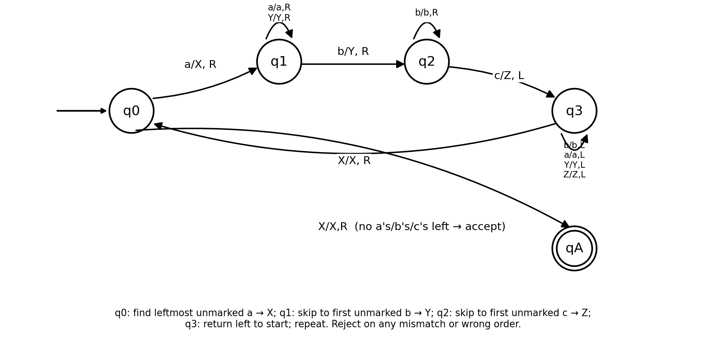
Fig. 5 — State diagram: one pass marks one a → X, one b → Y, one c → Z, then rewinds and repeats
Trace for input "aabbcc" (n = 2)
Pass 1: aXbbcc → XXbYcc → XXYbZc (mark a, b, c; rewind)
Pass 2: XXYYbZ Z-search → XXYYZZ (second a,b,c marked)
q0 finds no unmarked a → all b's are Y, all c's are Z, counts equal → ACCEPT
If at any pass q1 or q2 fails to find the required unmarked b or c (e.g. input "aabc" or "aabbccc"), the machine halts and rejects, correctly excluding strings that are not of the form aⁿbⁿcⁿ.

RUBRICS FOR CALCULATION

Criteria | Weightage | Level 4 –  Exemplary (5 Marks) | Level 3 –  Proficient (4 Marks) | Level 2 –  Developing (2–3 Marks) | Level 1 –  Beginning (0–  1 Mark)
Conceptual Understanding | 30 | Demonstrates clear and complete understanding of  the concept | Good understanding with minor gaps | Basic understanding with some  misconceptions | Poor or incorrect understanding
Accuracy of Answer | 25 | Completely correct answer with no  errors | Mostly correct with minor  errors | Partially correct with noticeable  errors | Incorrect or irrelevant  answer
Application of Knowledge | 20 | Correctly applies concepts to solve the  question/problem | Applies concepts with minor mistakes | Limited or partially correct application | No or incorrect application
Completeness of Response | 15 | Covers all required  parts of the question | Covers most  parts with minor omissions | Covers only some parts | Incomplete or  missing response
Clarity & Presentation | 10 | Clear, concise, and well-organized  answer | Understandable with minor  issues | Somewhat unclear or poorly  structured | Difficult to understand

